**GITHUB USING GUI**

**Part 1 – Create a Git repository**

Step 1 – Either you can directly click new repo on top right ‘+’ symbol or we can go to Repositries section and click on “New”.

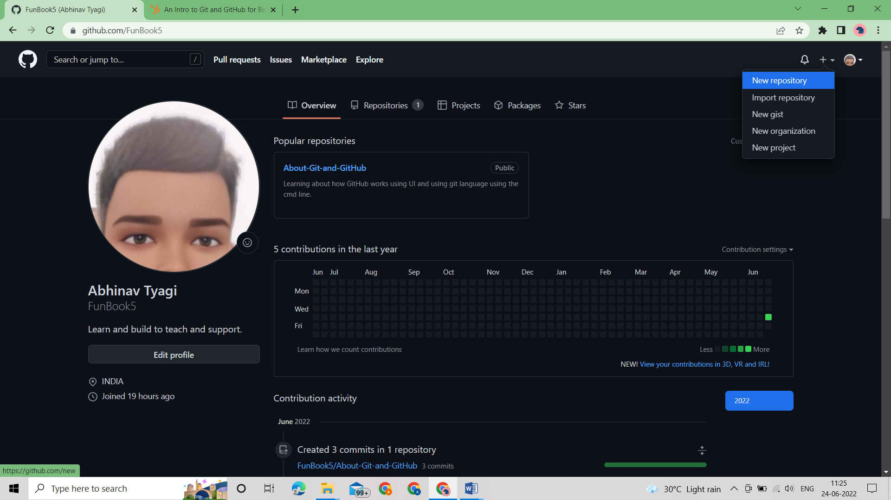

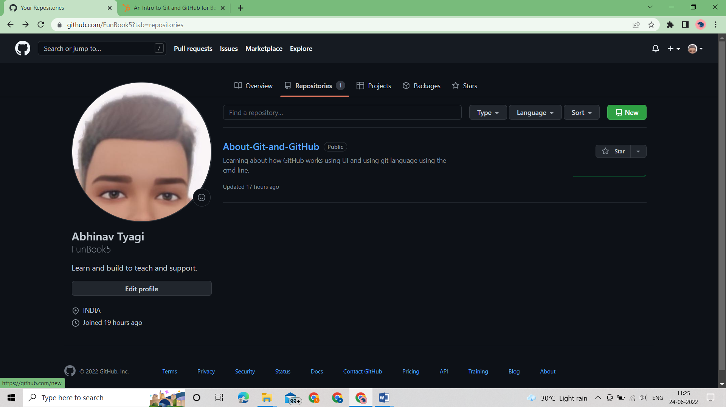

Step 2 – Fill the required details on the page, generally name and description are enough.

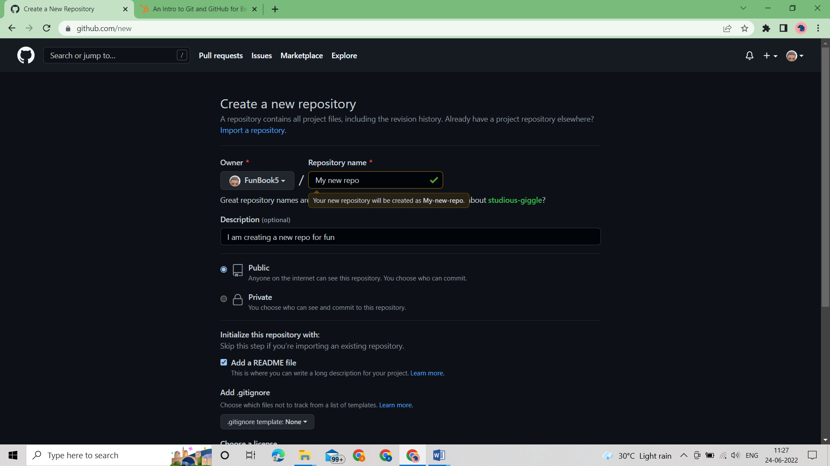

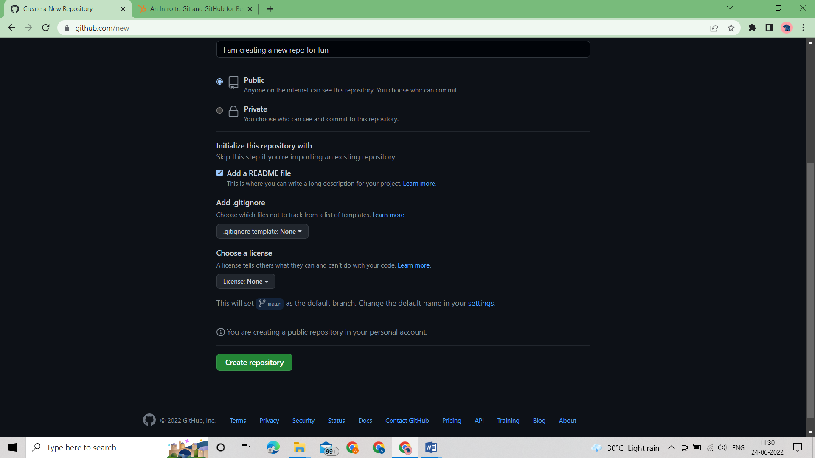

Step 3 – Repo is Created.

